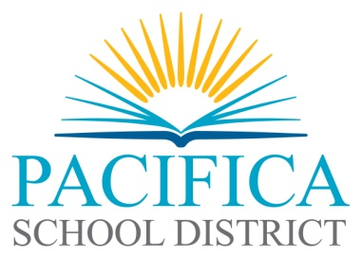

**Pacifica School District**

**Local Control Accountability Plan (LCAP) and**

**Proposed Budget for Fiscal Year 2022-2023**

**Balances in Excess of Minimum Reserve Requirement**

Per Education Code (EC) Sections 42127 and 52062 the Pacifica School District will hold public hearings on the proposed Local Control Accountability Plan (LCAP) and the proposed budget for fiscal year 2021-2022.

Education Code (EC) Section 42127(a)(2)(B) requires a statement of the reasons that substantiates the need for assigned and unassigned ending fund balances in excess of the minimum reserve standard for economic uncertainties for each fiscal year identified in the budget.

|  |
| --- |
| **NOTICE OF PUBLIC HEARING**  A public hearing to solicit the recommendations and comments of members of the public regarding the specific actions and expenditures proposed to be included in the LCAP and District Budget, and Balances in Excess of Minimum Reserve Requirements will be held during the next regularly scheduled meeting of the  **Board of Trustees at 7:00 p.m. on Wednesday, June 1, 2022**  The meeting will be held at the District Office  375 Reina del Mar, Pacifica  The meeting agenda will be posted on the District website on Friday, May 27, 2022. [www.pacificasd.org](http://www.pacificasd.org)  A copy of the LCAP, with the Budget Overview for Parents cover page,  and the proposed budget will be available for public examination at the  Pacifica School District, 375 Reina Del Mar Ave, Pacifica, CA 94044  from May 27, 2022 through June 1, 2022 between the hours of 8:00 am to 4:30 pm  and on the District website, [www.pacificasd.org](http://www.pacificasd.org). Please contact Josephine Peterson,  650-738-6613, [jpeterson@pacificasd.org](mailto:jpeterson@pacificasd.org) to request a printed or electronic copy.  Public members or stakeholders may request to comment at the public hearing on the LCAP and the Pacifica School District budget, or any item therein, by following the Instructions for Public Comment at Board Meetings found on the District website. |

Posted: District Website, District Office and District Schools